**Opening hours for Ballards Walk**

|  |  |  |
| --- | --- | --- |
| Monday | **08:00am** | **06:30pm** |
| Tuesday | **08:00am** | **06:30pm** |
| Wednesday | **08:00am** | **06:30pm** |
| Thursday | **08:00am** | **06:30pm** |
| Friday | **08:00am** | **06:30pm** |

**Opening hours for George Hurd Centre**

|  |  |  |
| --- | --- | --- |
| Monday | **08:00am** | **06:30pm** |
| Tuesday | **08:00am** | **06:30pm** |
| Wednesday | **08:00am** | **06:30pm** |
| Thursday | **08:00am** | **06:30pm** |
| Friday | **08:00am** | **06:30pm** |

**Please be advised, times at the George Hurd Centre are subject to change due to adapting to on the day appointment demand.**

**Patient Information Leaflet**

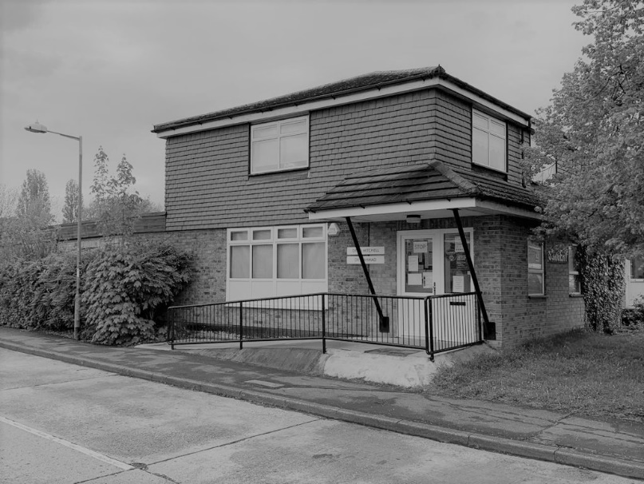

Ballards Walk Surgery is a partnership providing NHS Services under an NHS England General Medical Services Contract.

Ballards Walk Surgery

49 Ballards Walk

Basildon

SS15 5HL

George Hurd Centre

Audley Way

Basildon

SS14 2FL

Telephone No. 01268 542 901

Email address: ballards.walk@nhs.net

Website: www.ballardswalksurgery.nhs.uk

**Services we provide:**

Along with routine appointments, the practice offers the following services:

* **Family planning –** All our GPs and the practice nurse offer a full range of family planning services.
* **Immunisations –** The nursing team administers immunisations for children and seasonal vaccines for adults such as the flu and COVID-19 (certain criteria does apply for adults).
* **Cervical smear testing –** For women aged 25 – 65. These tests are undertaken by the nursing team.
* **Chronic disease management –** We hold a range of clinics to help our patients to manage their long-term medical problems including asthma, diabetes, hypertension, kidney disease and heart disease.
* **Other services –** Health checks for adult patients aged 16 to 74 years and 75 years and over are also available especially for those who have not seen a clinician at this practice. Details are available from reception and on the practice website.
* **Additional services -** We also offer the following clinics and checks: postnatal 6-8 week baby checks, smoking cessation, ECG, wound dressings, suture removal, and phlebotomy.
* **Private work –** Letter requests, medical reports and DVLA reports are, to name a few, requests that can be submitted and discussed with the senior partners who will decide fee.

From time to time, other services may be available such as raising awareness of a particular disease or condition. We will advertise this information on our website and within the practice.

**How to register at the practice -**

The quickest way to register at the practice is to come into the surgery and collect the registration forms. You are also able to register through our website. You must live within the practice area which is shown on the website.

**Updating your details –**

If any of your details have changed since your registration such as your name, marital status, and address, please let us know. You can print off the necessary forms from the website or collect from reception. Once completed, please bring the form into reception with a relevant piece of ID.

**Patients’ rights and responsibilities -**

When registering, you have a right to express a preference to be seen by a particular GP. This will be recorded on our clinical system and, where possible, you will be allocated appointments with that clinician. All patients will be assigned an accountable GP.

**West Basildon PCN –**

We work alongside other surgeries in the Basildon area including the following:

* Kingswood Medical Centre
* Laindon Medical Centre
* Noakbridge
* The Knares

We provide additional support and care through each of these surgeries by adding additional clinics throughout the week and a Saturday. These are clinics for Doctors, ANPs, HCA’s and Nurses to provide extra support to the area. Clinics can vary on location, but they primarily run 06:30pm to 08:00pm Monday to Friday and 09:00am to 05:00pm on a Saturday.

**Further information can be sought from** [**www.nhs.uk**](http://www.nhs.uk)

**The practice team -**This practice operates and provide services on behalf of the NHS.

**Partners –**

**Dr Alexander Mitchell**

**MBChB DRCOG BSc**

**Senior Partner (male)**

**Dr Nehal Ahmad**

**BSc MBBS**

**Senior Partner (male)**

**Salaried GPs –**

**Dr Josephine Otim**

**MBBS**

**Salaried GP (female)**

**Dr Mouli Roy**

**Salaried GP (female)**

**Nurse –**

**Reene Manu**

**Other healthcare staff -**

**Physicians Associate – Tanya Bass**

**HCA – Mrs Tracey Morgan**

**Practice manager –**

**Mrs Jacqueline Mellia**

heads our team of receptionists, secretaries, and administration staff. All the staff are here to assist you with any problems or queries you may have.We endeavour to provide a professional service throughout our catchment area, but it you do have any concerns, please contact the Practice Manager.

**Comments, suggestions, and complaints -**

If you would like more information about any of the services we provide, please ask a member of staff, telephone, or log into the practice website. Details are shown on the front of this leaflet.

Our aim is to give the highest possible standard of service. We would like you to tell us what you think about the service we

**Home visits -**

Home visits are at the discretion of the GPs and are usually for those patients who are housebound or have significant health issues. Should you require a home visit, please contact reception requesting a call-back after logging a call as early as possible. A clinician will then telephone you to discuss your request.

Home visits are usually carried out Monday to Friday. You may only request a home visit if you are housebound or too ill to attend the surgery.

**When we are closed -**

When the practice is closed, if you urgently need medical help or advice and it is life threatening, dial 999. If it is not life-threatening, contact NHS 111 by calling 111 or accessing via [www.nhs.uk](http://www.nhs.uk)

**Appointments and accessing practice services -**

To make an appointment to see your GP or any member of our healthcare staff or to access any other of our practice services, please ring **01268 524 901** and a member of our administrative staff will be able to assist you. We do not make appointments at reception. We only book GP appointments on the day.

The practice website contains all the relevant practice information that you are likely to require. It is the quickest way to access the services you may need.

**Threats of violence or abuse of staff -**

Our staff work hard to provide you with the best possible service. Please treat them with the courtesy and respect they deserve. We operate a zero-tolerance policy and may refuse to provide services to individuals or those accompanying individuals who are violent, threaten violence, commit, or threaten to commit a criminal offence.

**Patient** **Participation Group -**

We have an active Patient Participation Group (PPG), ensuring that our patients are involved in decisions about the services provided by the practice.

Further information about our PPG is available online at www.ballardswalksurgery.nhs.uk

**Patient data -**

All clinical and administrative staff have an ethical as well as a legal duty to protect patient information from unauthorised disclosure and in accordance with UK GDPR.

The patient privacy notice is available on the practice website.

**NHS England Contact -**

Ballards Walk Surgery provides NHS services on behalf of NHS England, PO Box 16738, Redditch, B97 9PT.

Telephone: 0300 311 2233

Email: [england.contactus@nhs.net](mailto:england.contactus@nhs.net)

**Prescriptions/repeat prescriptions -**

Your GP will initiate any prescription that they determine you require. You can have your prescription sent to a pharmacy of your choice. Repeat prescriptions can be ordered in the following ways:

* In person – By ticking the required medications on your prescription and placing it in the dedicated box, located in the surgery.
* Email – Please email mseicbb-b.prescriptions.ballardswalk@nhs.net
* My GP app/ NHS app – by having access to these apps, you can send easily send medication requests to the surgery.

**Please allow up to 72 hours for collection (excluding weekends and bank holidays) when ordering repeat prescriptions.**